NotebookLM: Your AI-Powered Research Assistant

Written by: Samiya Zaman | 2311537042

Introduction:
NotebookLM is a free AI-powered research tool by Google, built on the Gemini model, designed to help students, researchers, and professionals extract insights from their own documents. Unlike general chatbots, it grounds every answer strictly in the sources you provide — making it ideal for academic work, exam preparation, and report writing where accuracy is critical. It accepts PDFs, Google Docs, web URLs, and more, transforming dense material into summaries, quizzes, podcasts, and visual aids within seconds.

Key Features & Extraordinary Capabilities:
- Upload multiple files (PDFs, Word docs, Google Docs, Slides) from your computer or Drive — up to 50 sources per notebook.
- Paste a website URL directly as a source; the AI fetches and reads the webpage for you, enabling real-time web grounding.
- One-click generation of Study Guides, FAQs, Glossaries, Timelines, Briefing Documents, Flashcards, Quizzes, Slides, and Infographics.
- Audio Overview: converts your sources into a fully produced, two-host AI podcast — unique among all mainstream AI tools.
- Every answer includes inline citations linking back to the exact sentence in your source document for full transparency.

What Makes NotebookLM Stand Apart from Other AI Tools:
Most general-purpose AI tools — ChatGPT, Gemini, Claude, Copilot — are trained on vast internet datasets and generate answers from that broad pre-trained knowledge. This makes them versatile but also prone to hallucination: they can confidently produce facts that are inaccurate or not present in your actual documents. NotebookLM is architecturally different. It operates as a closed-source notebook — it reads only what you give it, and if a topic is not covered in your sources, it tells you rather than guessing.
Tools like Perplexity AI also cite sources, but they pull from the open web in real time, meaning you have no control over what information the AI is reading. NotebookLM gives you full control: you decide exactly which documents, papers, or URLs the AI is allowed to reason from. Unlike Google’s own Gemini which blends web knowledge with your files, NotebookLM enforces a strict boundary between your curated sources and the outside world. This source-locked behavior is what makes it uniquely suited for academic research, legal document review, and any task where you must be able to trace every claim back to a specific, verifiable passage.

Prompt:
Using NotebookLM’s built-in web search feature, the query “article about July Revolution in Bangladesh” was entered. The AI suggested a comprehensive list of related sources including news articles, analytical pieces, and historical summaries. All suggested sources were selected. NotebookLM then automatically ingested all the web content and set up the notebook with those sources as its knowledge base.

Output:
NotebookLM auto-generated a structured summary of all selected sources upon notebook creation. From this single notebook, the following outputs were generated using the tool’s built-in features: an Audio Overview podcast (two AI hosts discussing the revolution), a Mind Map, an Infographic, a Slide Deck, Flashcards, a Quiz, a Study Guide, and a Briefing Document. Two of these outputs are shown below — the Infographic and the Mind Map.
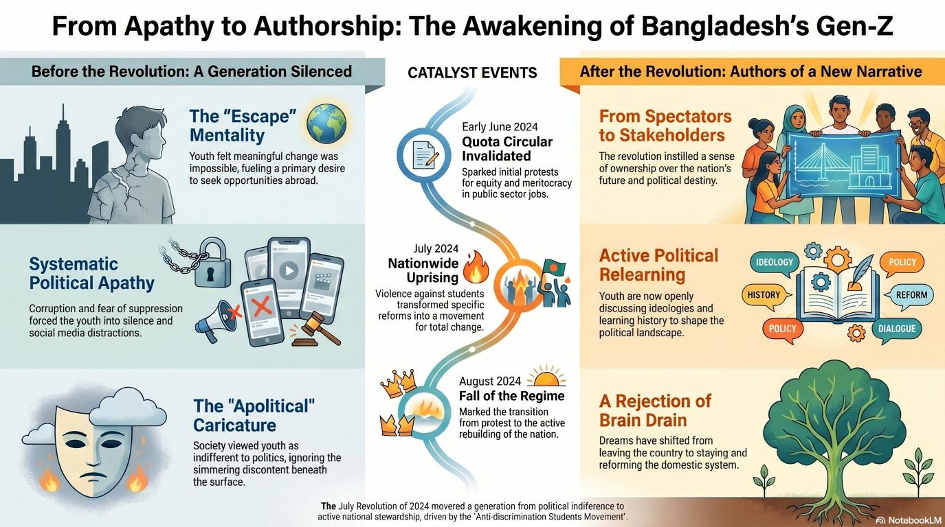
Figure 1: AI-generated Infographic — From Apathy to Authorship: The Awakening of Bangladesh’s Gen-Z

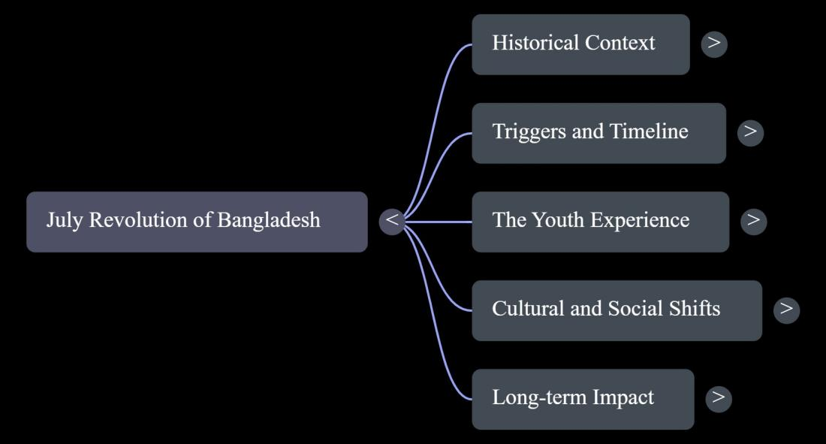
Figure 2: AI-generated Mind Map — July Revolution of Bangladesh

Prompt Engineering:
Tips to refine prompts for better outputs in NotebookLM:
- Specify the source scope: phrases like “from the lecture notes only” or “across all sources” make responses more targeted and precise.
- Ask for a specific output format: “give me a bullet-point list of 5 key findings” or “create a comparison table” produces more structured results than open-ended questions.
- Use multi-part prompts: NotebookLM handles compound instructions well — e.g., “First summarize, then generate 5 exam questions, then list key terms.”
- Add “and cite the specific passage” to any prompt when accuracy matters; this forces the AI to flag exactly where each piece of information was found.
- Iterate with follow-up questions: after an initial response, ask “Elaborate on point 3” or “Which source supports this most strongly?” since NotebookLM maintains session context.
- Specify the target audience: “Explain this as if I am a first-year student” or “Write in a professional tone suitable for a report” shapes both tone and depth significantly.

Conclusion:
NotebookLM occupies a uniquely valuable space in the AI landscape. Its strict source-grounding makes it far more reliable than ChatGPT for academic and professional tasks where citation accuracy is non-negotiable. Compared to Perplexity AI, which also cites sources but draws from the open web, NotebookLM gives you full control over the information space. It is not a replacement for general-purpose AI when you need creative writing or coding help, but as a personal research librarian — one that reads your documents, answers with proof, generates podcasts, mind maps, infographics, and quizzes from them — it is arguably the most practically useful AI tool available for students and researchers today.

*Note: This chapter was written with assistance from Claude (Anthropic).

